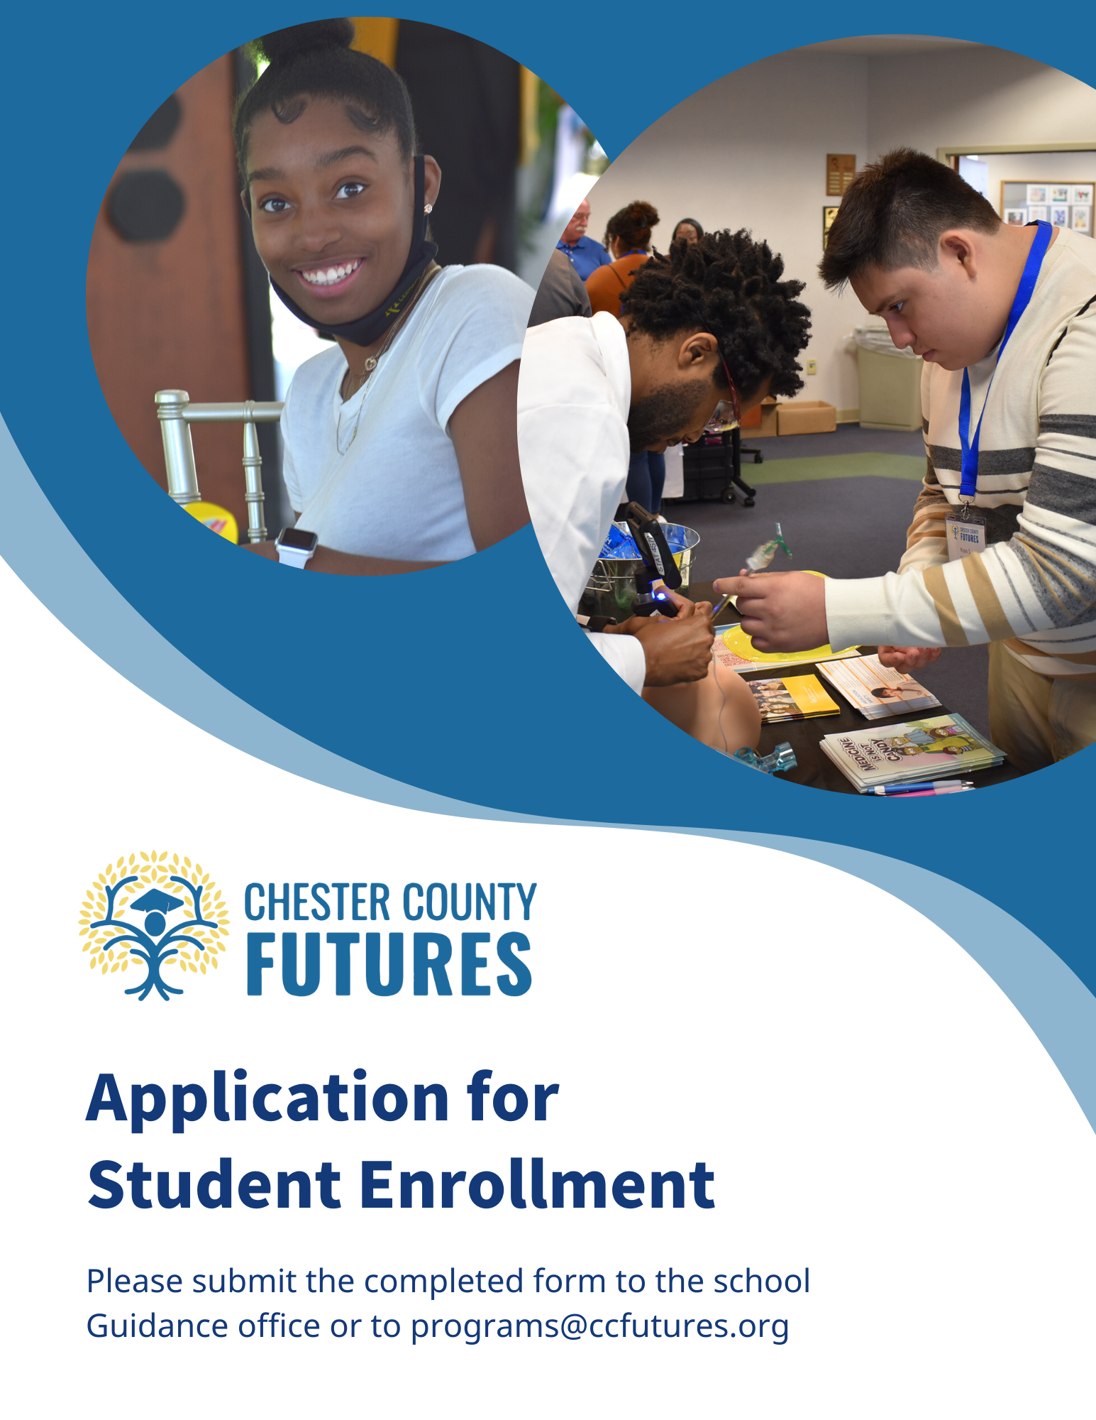

Parent Application

Please answer all questions thoroughly. Place the completed application in the envelope provided and return to the school’s Guidance office or e-mail programs@ccfutures.org.
Upon receipt of the completed application:
- Chester County Futures (Futures) staff will set up appointments through the Guidance office, to interview students at the school to determine their eligibility for the program.
- When a student is accepted into Futures, the parent and student will receive a acceptance letter.
- A representative from Futures may be in touch with you if there are any questions regarding this application.

Student’s Name: ______________________________ Date of birth: ______/______/______

Parent/Guardian Information:
Name of Parent/Guardian(s): (Please print) Address
_______________________________________ ______________________________________________

______________________________________ ______________________________________________

Phone:
Parent/Guardian 1: Home: _____________ Cell: _________________ Email: ________________________
Parent/Guardian 2: Home: _____________ Cell: _________________ Email: ________________________
Student: Home: ____________________ Cell: __________________ Email: _______________________

Student Application

Congratulations!

You have been nominated for the Chester County Futures program. Chester County Futures (Futures) is an academic enrichment, mentoring and post-secondary scholarship program that is offered to students like you who are motivated and wish to attend college or technical school, or enter the work force after high school.

We would like to get to know you! Please answer all questions thoroughly.

Student Questionnaire

Student Name: ______________________________________________________ Date: ______________

Please print clearly (you may use additional paper if you need more space)

Please give a brief explanation of how participating in Chester County Futures will help you to succeed?
___________________________________________________________________________________________________________________________________________________________________________________________________________________________________________________________________________
_________________________________________________________________________________________

What are your post-high school goals?
___________________________________________________________________________________________________________________________________________________________________________________________________________________________________________________________________________
_________________________________________________________________________________________

Student Questionnaire (Continued)

What do you do in your spare time? Are you involved in any activities or clubs in school or in your community? ___________________________________________________________________________________________________________________________________________________________________________________________________________________________________________________________________________
_________________________________________________________________________________________

What career field(s) interest you and why? ___________________________________________________________________________________________________________________________________________________________________________________________________________________________________________________________________________
_________________________________________________________________________________________

Please tell us any additional information about yourself that you would like us to know. (Please use additional paper if necessary.)
____________________________________________________________________________________________________________________________________________________________________________________________________________________________________________________________________________________________________________________________________________________________________
__________________________________________________________________________________________________________________________________________________________________________________
____________________________________________________________________________

Student Commitment Form

Chester County Futures requires a significant commitment on the student’s part. Once you are accepted into the program, you must attend weekly after-school meetings.

Will you be able to make that commitment? _____ Yes _____ No _____ Maybe

Please explain your answer: ___________________________________________________________________________________________________________________________________________________________________________________________________________________________________________________________________________
_________________________________________________________________________________________

Academic and Program Standards for Chester County Futures

- Maintain a minimum “C” average in all classes.

- Attend school.

- Attend all Chester County Futures meetings.

- Display mature and respectful conduct in and out of classroom.

- Attend all Chester County Futures student special events.

- Participate in at least one community volunteer activity event per year.

Student Signature: _____________________________________ Date: ___________________

